8. **DESIGN OF MONOSTABLE AND ASTABLE MULTIVIBRATOR USING IC555**

**8.1 OBJECTIVE**

1. Design a Monostable multivibrator for an ON- time of 11secs, with capacitor value of 1 µF. Conduct the experiment and plot appropriate graphs
2. Design an Astable multivibrator for a frequency of 1KHz with 60% duty cylcle using 555 timer

**8.2 HARDWARE REQUIRED**

|  |  |  |  |
| --- | --- | --- | --- |
| **S.No** | **Equipment/Component name** | **Specifications/Value** | **Quantity** |
| 1 | IC 555 Timer | Refer data sheet in appendix | 1 |
| 2 | Cathode Ray Oscilloscope | (0 – 20MHz) 1 | 1 |
| 3 | Resistors | 330 Ω  15K Ω  10 M Ω  6.8 K Ω  1K Ω | 1  1  1  1  1 |
| 4 | Capacitors | 0.1µf  1µf | 2  2 |
| 5 | Regulated power supply | 1. -5V), 1A | 1 |

**8.3 THEORY**

The 555 Timer is a monolithic timing circuit that can produce accurate and highly stable time delays or oscillations. The timer basically operates in one of the two modes—monostable(one-shot) multivibrator or as an as table(free-running) multivibrator. In the monostable mode, it can produce accurate time delays from microseconds to hours. In the astable mode, it can produce rectangular waves with a variable duty cycle. Frequently, the 555 is used in astable mode to generate a continuous series of pulses, but you can also use the 555 to make a one-shot or monostable circuit.

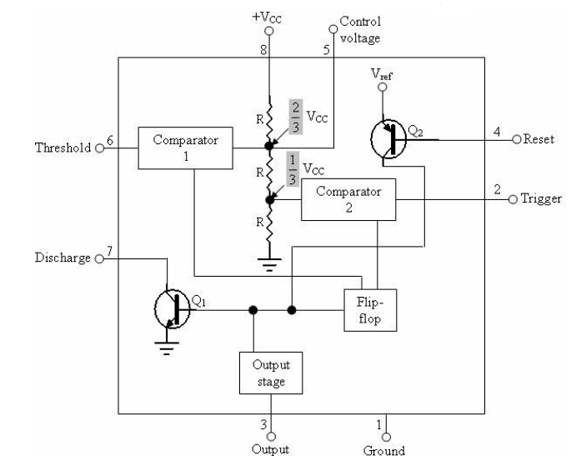

*Functional block diagram of IC 555*

In astable or free running mode, the 555 can operate as an oscillator. The uses include LED and lamp flashers, logic clocks, security alarms, pulse generation, tone generation, pulse position modulation, etc. In the bistable mode, the 555 can operate as a flip-flop and is used to make bounce-free latched switches, etc.

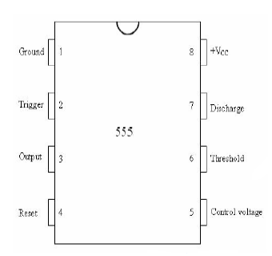

**Pin diagram of IC55**

**8.3.1 MONOSTABLE MULTIVIBRATOR**

The circuit has an external resistor and capacitor. The voltage across the capacitor is used for the threshold to pin 6. When the trigger arrives at pin 2, the circuit produces output pulse at pin 3. Initially, if the output of the timer is low, that is, the circuit is in a stable state, transistor Q1 is on and the external capacitor C is shorted to ground. Upon application of a negative trigger pulse to pin 2, transistor Q1 is turned off, which releases the short circuit across the capacitor and as a result, the output becomes high. The capacitor now starts charging up towards vcc through RA. When the voltage across the capacitor equals 2/3vcc the output of comparator 1 switches from low to high, which in turn makes the output low via the output of the flip-flop. Also, the output of the flip-flop turns transistor Q1 on and hence the capacitor rapidly discharges through the transistor. The output of the monostable multivibrator remains low until a trigger pulse is again applied. The cycle then repeats. Below figure shows the trigger input, output voltage, and capacitor voltage waveforms. As shown, the pulse width of the trigger input must be smaller than the expected pulse width of the output waveform. Moreover, the trigger pulse must be a negative-going input signal with an amplitude larger than 1/3 vcc. The time for which the output remains high is given by time period = 1.1RAC

Where *R*A is in ohms, C in farads and time period in seconds. Once the circuit is triggered, the output will remain high for the time interval time period. It will not change even if an input trigger is applied during this time interval. In other words, the circuit is said to be non-retriggerable. However, the timing can be interrupted by the application of a negative signal at the reset input on pin 4. A voltage level going from +vcc to ground at the reset input will cause the timer to immediately switch back to its stable state with the output low.

The trigger input may be driven by the output of astable multivibrator with high duty cycle. If the desired pulse width is of the order of seconds, the output can be seen using a LED and the resistance value used will be of the order of MΩ. In this case the trigger can be supplied manually by grounding the trigger input for a fraction of a second.

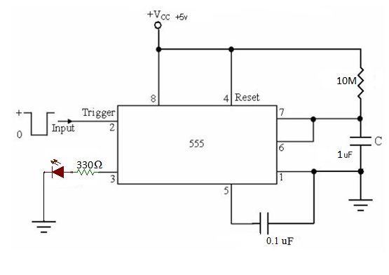

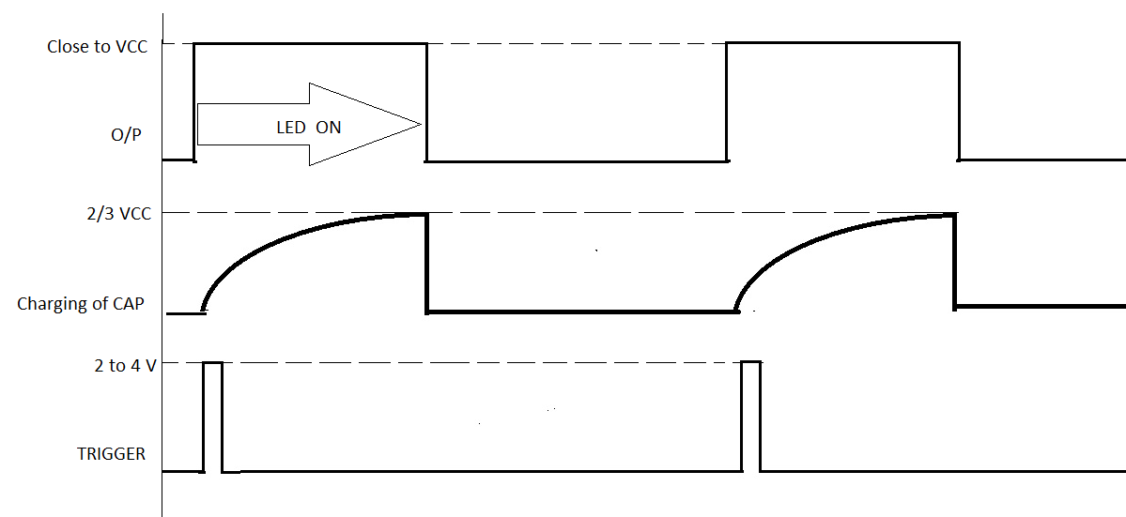

*Input and output waveform*

**Design**

Time period of pulse=T=1.1RC=11s

Let C=100f

T=1.1RC

11s=1.1*R*1uf

R=10M

**8.3.2 ASTABLE MULTIVIBRATOR**

An astable multivibrator is a wave-generating circuit in which neither of the output levels is stable. The output keeps on switching between the two unstable states and is a periodic, rectangular waveform. The circuit is therefore known as an ‘astable multivibrator’. Also, no external trigger is required to change the state of the output, hence it is also called ‘free-running multivibrator’. The time for which the output remains in one particular state is determined by the two resistors and a capacitor externally connected to the 555 timer.

If the output is high initially, capacitor C starts charging towards vcc through RA and RB. As soon as the voltage across the capacitor becomes equal to 2/3 vcc, the upper comparator triggers the flip-flop, and the output becomes low. The capacitor now starts discharging through RB and transistor Q1. When the voltage across the capacitor becomes 1/3vcc, the output of the lower comparator triggers the flip-flop, and the output becomes high. The cycle then repeats.

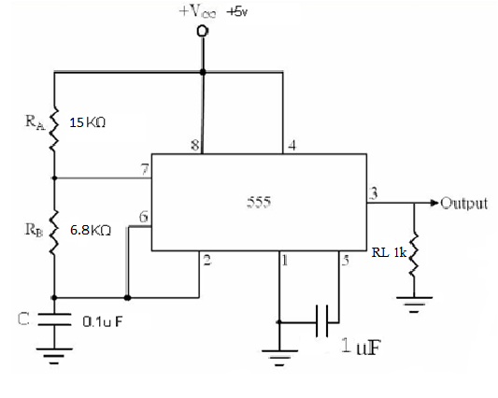

The output voltage and capacitor voltage waveforms are shown in Figure below.

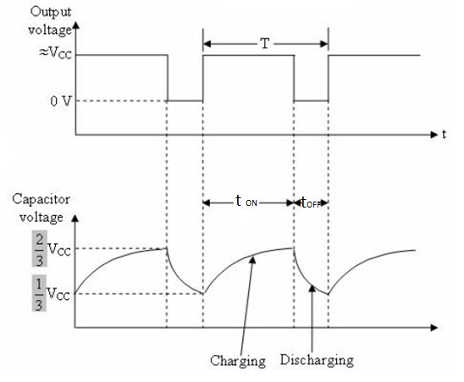

*Output voltage waveform*

the time during which the capacitor charges from 1/3vcc to 2/3 vcc is equal to the time the output is high and is given by

ton =0.69(RA + RB)C

the time during which the capacitor discharges from 2/3vcc to 1/3vcc is equal to the time the output is low and is given by

toff =0.69RBC

the total period of the output wave form is

T=ton+toff=0.69(RA+2RB)C

Thus the frequency of oscillation is

fo=1/T=(1.45/(RA+2RB)C)

**Design Constraints**

* The 555 Timer is a very versatile low cost timing IC that can produce a very accurate timing periods with good stability of around 1%
* Duty cycle should be greater than 50% to 80%
* Single RC network connected to a single positive supply of between 4.5 and 16 volts.
* Load resistance minimum value is 1KΩ

|  |  |  |  |
| --- | --- | --- | --- |
| **Theoretical O/P** | | **Practical O/P** | |
| TOTAL TIME |  | TOTAL TIME |  |
| TON |  | TON |  |
| TOFF |  | TOFF |  |
| AMPLITUDE of  Square . | Close to VCC | AMPLITUDE of  Square . |  |
| Charge & Discharging  Of Capcitor by measuring Amplitude | 2/3 VCC – 1/3 VCC  3.3 – 1.6 = 1.7 v | Charge & Discharging  Of Capcitor by measuring Amplitude |  |

* 1. **PRE-LAB**

Choose the correct answer

1.A quasi-stable state is such that the output

1. a) does not change at all

b) Changes unpredictably

c) Changes after a predetermined period of time

d) Changes just after a very short duration of time.

2. A monostable multivibrator is also called a ‘one-shot multivibrator’ because

a) Each time a trigger pulse is applied, the circuit produces a single pulse.

b) The circuit has to be triggered only once

c) The output pulse duration is very small

d) None of the above.

3.For a 5 V circuit, If pin 4 is taken to 1 V, does the chip reset?

1. Yes
2. No
3. Cannot be determined

**8.5 POST LAB QUESTION**

1. If the diode is connected across RB in the astable multivibrator circuit, what is condition on RA and RB to achieve duty cycle of 50%?
2. **Why the control voltage pin (pin 5) of 555 timers is connected to ground through a 0.01µf capacitor?**
3. **Calculate the ON time, OFF time, Total time period, Duty cycle and Frequency of the output generated by an astable multivibrator using resistors RA = 5k, RB =5K and capacitor C = 10µf.**
4. **Why the Reset pin of IC555 is normally connected to Vcc?**

**RESULT:**

